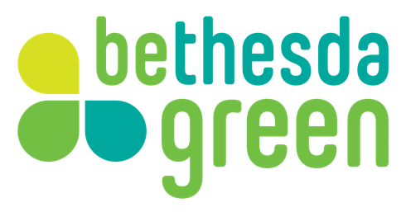

Bethesda Green Innovation Center
Application Questions for F6S.com

- In one sentence, tell us what your company does and what the products/services are that you offer.
- Vision Statement – why did you start your company? Tell us about your passion.
- Why do you want to participate in Bethesda Green’s Innovation Lab?
- Have you formed as a legal business entity? If yes, what type of entity (C Corp, LLC, etc.)?
- In what US state is your entity registered?
- Currently, in which country are your venture’s main operations?
- How long have you been working on this start-up?
- Please include the names of all members of the founding team, including titles (if applicable).
- How many employees are full-time (including yourself)?
- Please select the option that best describes the stage of development of your product or service.
  - I do not have a physical product or prototype.
  - I have a prototype or simple version that I can show customers.
  - I have a market-ready product / service. I could sell it to customers.
  - I have a market-ready product / service. I have sold it to customers.
- What is the current operational model of your venture?
  - Production / Manufacturing
  - Processing / Packaging
  - Distribution
  - Wholesale / Retail
  - Services
  - Financial Services
  - Unsure
- Does your venture have any of the following?
  - Patents
  - Copyrights
  - Trademarks
- What is your total revenue to date? ($USD)
- Do you plan to raise investment capital within the next year?
- How much of their own money have founders put into the business since founding?
- Please indicate whether your venture has received any of the following investment from outside sources since founding.
  - Equity (money received in return for some portion of ownership)
  - Debt (not including any personal debt obtained on behalf of the business)
  - Philanthropy (seed grants, awards, or donations)
  - The venture has not received any funds from outside sources.
- Besides funding, what are your top two most significant business challenges at this point and why?
- Does your venture regularly track its impacts using any established measurement (IRIS, GIIRS, GRI, SASB) approaches?
- What is some of the best advice you’ve received since you’ve founded your business? Why?
- How do you describe yourself as an entrepreneur?
- Have you been, or are you currently a member of another incubator or accelerator program? If yes, which one(s)?
- From the list below, what are the TOP 3 MOST IMPORTANT benefits of an entrepreneurial support organization to you?
  - Network development (eg with potential partners and customers)
  - Business skills development (eg finance and marketing skills)
  - Mentorship from business experts
  - Access and connections to potential investors / funders
  - Securing direct venture funding (eg grants or investments)
  - Gaining access to a group of like-minded entrepreneurs
  - Awareness and credibility (eg association with a recognized program, press / media exposure)
- How did you hear about the Innovation Lab at Bethesda Green?
- Please include a 2-page executive summary (preferred) or a short pitch deck that addresses the following questions (max file size, 30MB). Note: We understand that you may not have all of the below ironed out; please be candid on what you're still working on. This is about understanding your idea, where you're at now, and how we can help you.
  - Management Team– What strengths does your team bring in making this company a success?
  - Customer- What is your target customer segment? Who pays, benefits and uses your product/service?
  - Problem- What problem are you solving for your customers?
  - Solution – How does your product/service address the problem and create value?
  - Target market- What is the size and projected growth of your market?
  - Business Model – How will you generate revenue? What is your business model? Be specific, indicate your primary revenue streams, and describe your distribution channels.
  - Competition –Who are your primary direct and indirect competitors, as you view them? What is your competitive advantage?
  - Market Traction- What is your current progress or traction to date? Please include pilots, customers and/or users, market feedback, partnerships, revenue, and/or any other indicators of progress.
- By submitting this information you are giving it to Bethesda Green to use internally at its discretion. The information collected in this application is considered confidential, and will not be shared beyond the Bethesda Green Innovation Lab team, our trusted network of mentors and advisors, and the board of directors without your permission. You will be opting in to receive newsletters from Bethesda Green and the Innovation Lab.
By checking this box and submitting your application to Bethesda Green for review, you agree that you've read and understand the statement above, and that these are your original ideas and concepts that you have full legal rights to submit.

